**Epics:**

**User stories:**

**1.Login Module:**

1.a. User Login:

1.b.Forgot Password:

1.c.Captcha Verification:

**2.Account details:**

2.a.Account details:

2.b.Modify details:

2.c.Change Password

**3.Money Transfer:**

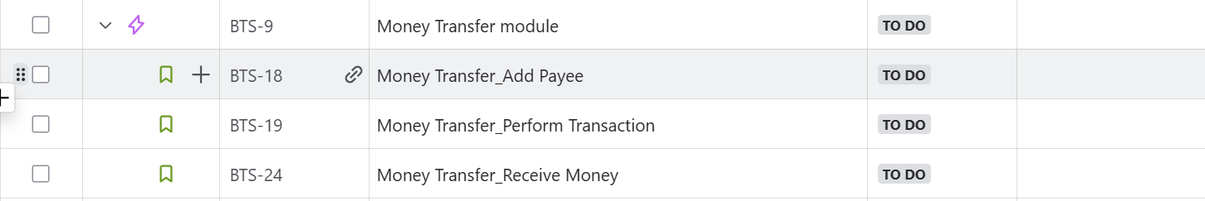

3.a Add Payee:

3.b Perform Transaction:

3.c. Receive Money:

**4.Report Generation:**

4.a.Account balance:

4.b. Money Transfer details:

4.c.Statement Generation:

**5.Logout:**



5.a.Logout:

